

ENTREPRENEURSHIP

MENTORSHIP PROGRAMME

Establishment of E-Cell in different Technical and non-Technical colleges of

JHARKHAND



|  |  |  |
| --- | --- | --- |
| DR. SHAKTI P. PATTANAYAK | DR. BIMAL KR. MISHRA | ROHAN YADAV |
| Advisor, EDC BIT-Mesra | DSW, BIT-Mesra | President, EDC BIT-Mesra |

ENTREPRENEURSHIP DEVELOPMENT CELL-BIT MESRA

Entrepreneurship in India is yet to reveal its hidden potential. It will not only help India to frontier with world leaders but also unlock the quality of brains that we are so proud of. With this idea, The Entrepreneurship Development Cell, BIT Mesra wishes to inculcate and Enrich the entrepreneurial environment in India by creating an easily acceptable and exhaustive set of resources for the entrepreneur, which including the students, the budding professionals, mentors, angel investors and the venture capitalists through various fun-filled yet educating sessions such as Commence Mint-The startup school, eTalks and so on and so forth.

**What is Entrepreneurship Development Cell (EDC)?**

Entrepreneurship Development Cell was established in 2007 under the aegis of

STEP (Science and Technology Entrepreneurs’ Park).

The Entrepreneurship Development Cell is a non-profit organization run by the students in support by administration of BIT Mesra dedicated to promote the spirit of entrepreneurship among the students of college and region.

We at EDC host various workshops, speaker sessions, innovative games and competitions for aspiring Entrepreneurs and support them by providing necessary resources.

Entrepreneurship Development Cell as the name suggests aims at developing Entrepreneurship in the college. EDC helps at creating awareness about the entrepreneurship as a career choice, funding startups, registering the startups and helping them in decision making.

The Vision of the Entrepreneurship Development Cell is to create a sustainable and diverse entrepreneurial eco-system where the young and the experienced come together to take entrepreneurship a step ahead in India.

**What Entrepreneurship Development Cell does?**

EDC’s prime objective is to be a stepping stones for students who want to take the unconventional path and start their own enterprise.

The major area of focus for EDC is to gather the required expertise for interested students and help them approach Venture Capitalists (VC’s) and banks for funding.

EDC also plays a vital role in encouraging entrepreneurship among students of Jharkhand region through workshops, activities and guest lectures by eminent personalities.

Another objective of EDC is to provide Mentorship opportunities to students from alumni and other startups. EDC serves as a channel between the two, helping the student get the right mentor and vice versa. We, at Entrepreneurship Development Cell organize various events and workshops.

Following are the events organized and initiatives taken by EDC which help us to keep us focused on our aim-

**1. Entrepreneurship Talks:**

Entrepreneurship Talk is a flagship event of EDC BIT Mesra. In E-Talk we chose a hot topic from the start up world and discuss it with the members of the cell.

E-Talk aims to create awareness about different things going in the mesmerizing world of Entrepreneurship among students at campus.

**2. Workshops:**

Workshops tend to have a large impact on the task encouraging the spirit of entrepreneurship in young minds. These workshops focus on a wide variety of topics and aim at building a broader understanding of new forms of innovation and analyzing the key challenges posed to entrepreneurs.

**3. Guest Lectures:**

Various Guest Lectures are conducted as part of our Entrepreneurship Awareness initiative. Talks by various authorities on entrepreneurship are conducted, as they serve as motivation as well as guide-posts for aspiring entrepreneurs. Some of the topics covered in these lectures are of prime importance for new startups.

**4. Competitions:**

Taking competitions to be incentives of progress, we constantly strive to achieve greater heights of expertise in our fields by competing with others as well as our own selves. It’s not just about winning but competing with everything that we have got which gives us an adrenaline rush which is our kind of high.

**5. Start Up fair:**

EDC organizes a start-up fair every year to give startups a platform to showcase their products. Startup Fair is a platform which involves interaction of Entrepreneurs and students and aims to help Start up to recruit the finest talent for internships/jobs.

**6. Innovatory:**

Innovatory exposes students to real life problems and promote them to apply their skills and knowledge to improve on the current business models.

We select some real life problem at our campus and solve them with existing resources available and innovative brains of students.

**7. Entrepreneurship Awareness Program:**

With a view to expose students as well as faculty of academic institutions, offering degree/diploma courses in Science & Technology, to entrepreneurship as an alternative career, Entrepreneurship development cell (EDC) of BIT Mesra organize Workshops, Guest lectures and competitions in different colleges of the state.

**8. Campus CEO:**

To create an Ecosphere of entrepreneurship in Jharkhand state and develop entrepreneurial outlook among students, and provide budding entrepreneurs a platform to showcase their services to the youth crowd of the state. EDC selects one/two Campus CEO(s) from a number of colleges across Jharkhand. Each Campus CEO will work with a startup for one month and help them promote products/services in the locality of his/her college.

**Achievements of Entrepreneurship Development Cell-BIT Mesra:**

* **Winner** of Entrepreneurship Summit 2016, IIT, Bombay among 150 competing E-Cells.
* **Winner** of National Entrepreneurship Challenge 2014, IIT BOMBAY  
  among 120 E-Cells in the country.
* EDC Member Akshay Jalan, received recognition from the Stanford University, for being among the **Top 100** College Entrepreneurs across  
  the world.
* **1st** in Master Plan conducted by IIM-Ahmedabad at Confluence’12.
* **1st** in B-Plan Competition conducted by Indian Institute of Foreign Trade,  
  New Delhi.
* **1st** in B-Plan Competition conducted by IIT – Bombay as part of Eureka’12.
* Selected in the final round of TiE Asia Level**.**

A deep dive into functioning of Entrepreneurship Development Cell-BIT Mesra.

**EDC Activities - 2011/12**

**BIT Mesra has an active Entrepreneurship Development Cell working in close association with STEP.**

The cell regularly organizes various events. Some of the events organized in the past 1 year worth mentioning are:

1. **E. Week** : April 1st to April 7th 2011

Entrepreneurship Development Cell, BIT Mesra & STEP, BIT organized an E-Week from 1st – 7th

April 2011.

The objective was to make students aware about entrepreneurial and intrapreneurial mind. Some of the senior and experienced faculty members, senior practicing managers / lending bankers/ policy makers as well as entrepreneurs were invited to elaborate on the above mentioned subject during different sessions of the workshop.

The distinguished guests and speakers who attended the event are given below:

|  |  |
| --- | --- |
| **SPEAKER** | **TOPIC** |
| Dr. Ajay Chakrabarty (Vice Chancellor, BIT Mesra) | Inaugural Session |
| Dr. S.K. Bose (HOD, Department of Management) | Introduction & Financial aspects of  Entrepreneurship |
| Mr. Santosh Kumar Rana (Asst General Manager SBI) | Entrepreneurship Process |
| Dr. Hari Haran (General Mager, MTI, SAIL, Ranchi) | Corporate Entrepreneurship |
| Mr. Mahesh Venkateswaran (CEO, Krishi Gram Vikas  Kendra (KGVK), Usha Martin ) | Ecosystem based Social Entrepreneurship in the Indian Context |
| Mr. Tarak Nath Shaw (Alumni and Faculty at ICFAI) | Entrepreneurial Process |
| Mr. Samad (AGM, Small Industries Development Bank of India) | Government Policies and Norms for  Entrepreneurs |
| Dr. R.P. Bhatnagar (Principal Scientific Officer, BIT Mesra) | Intellectual Property Rights (IPR) issues for  Entrepreneurs |

A panel discussion was also organized at the conclusion of the event

|  |  |
| --- | --- |
| **NAME** | **DESIGNATION** |
| Mr. S.K. Agarwal | Alcast, Alumni and Entrepreneur |
| Mr. N.C. Agarwal | Meditron, Alumni and Entrepreneur |
| Mr. S. Ghosh | Transcon, Alumni and Entrepreneur |
| Mr. Mahesh Venkateswaran | CEO, Krishi Gram Vikas Kendra (KGVK), Usha Martin |

|  |  |
| --- | --- |
| **NAME** | **DESIGNATION** |
| Mr. Tarak Nath Shaw | Alumni and Faculty at ICFAI |

2. **B.Plan Competition**: 5th – 6th November 2011

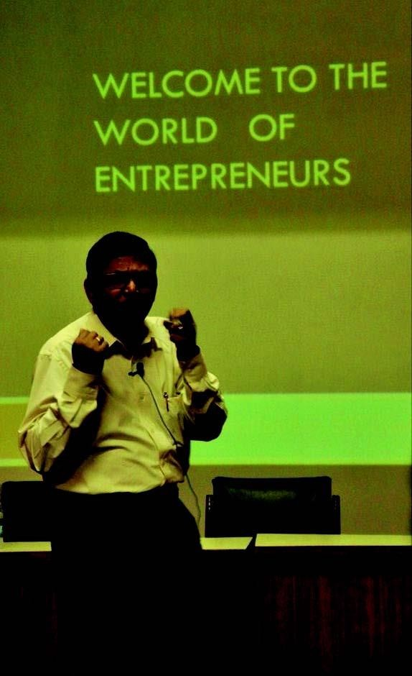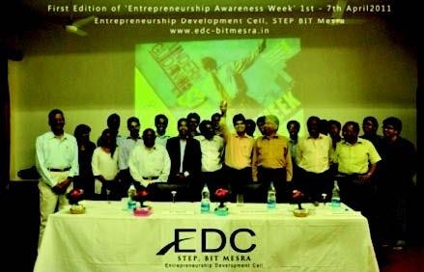

EDC, BIT Mesra organized a workshop on "How to make your own B-Plan". It was conducted by **Rahul Anand** (PGP 2011, IIM Ahmedabad; B.Tech CSE 2005-2009 ,BIT Mesra ) who is currently running his own educational startup **B-Factory** at Ranchi. It was a two day workshop and broadly covered following topic:

Idea Generation (Helping Trigger your creativity), get to know the upcoming new fields and latest trends

How to generate Cash Flow Models and financial charts for your startups

How to write a Business Plan which has the right impact?

How to approach Venture Capitalists and Angel Investors?

Get to know the technical terms involved while running or designing a startup

The program started on day 1 with the introduction to B-Plan, idea generation, successful B-Plan, discussion and distribution of group in 4 or 8

Day 3 begin with the presentation by groups, details on how to build their own cash flow model, and how to pitch ideas to venture capitalists etc.

3.  **Joyf est ’11**

**It is a national strive towards the well-being of humanity. It’s a movement**

**where students do acts of giving, and get together as one for the underprivileged. The**

**Entrepreneurship Development Cell, STEP, BIT Mesra organized it from October**

**10th to October 16th in collaboration with NGOs like Pratham, Needs, Jan Sewa Shakti**

**Samiti, Samvedna, Cheshire Home, Vrisha Aashram and St. Michael’s Blind School.**

**A total of around 75,000/- Rs were collected which was spent on providing stationary and other daily needs to blind students & other schools in the campus. Over 20k cloth materials were collected and equal number of books and other items were donated generously by the people utilized to serve the needy.**

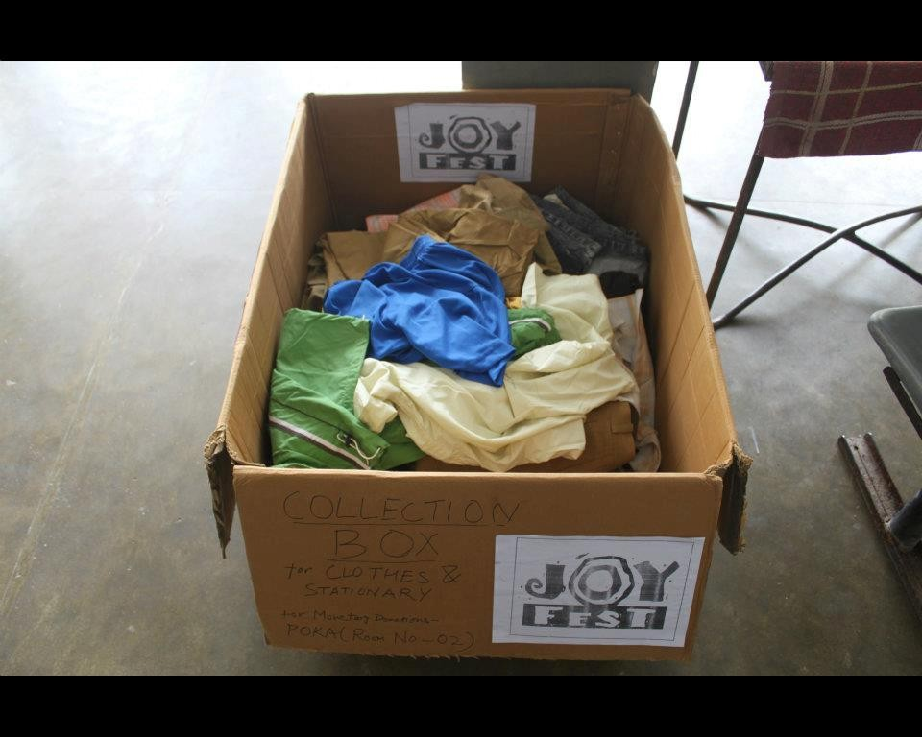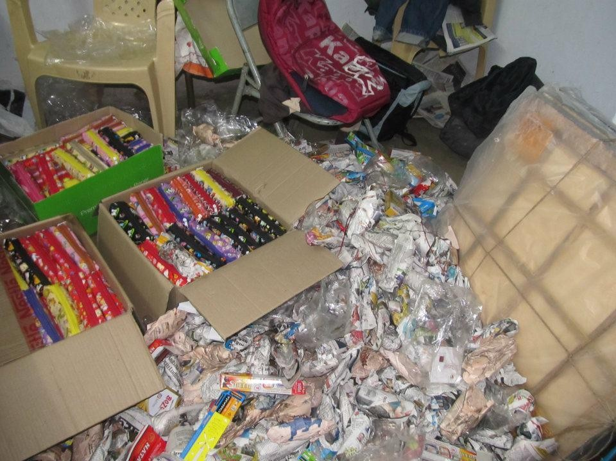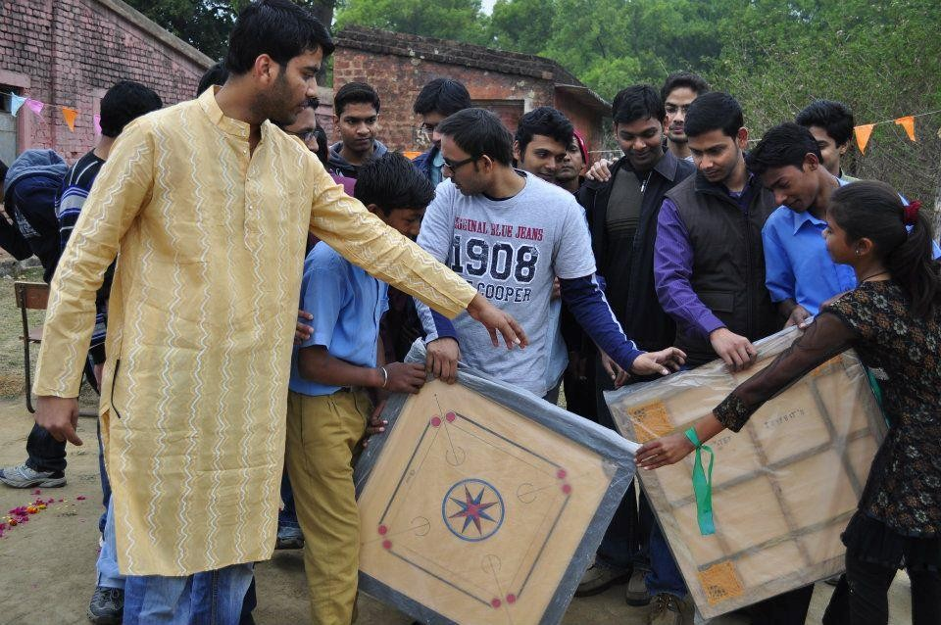

8

**Entrepreneurship Development Cell, BIT, MESRA**

**Report 2013-2014**

**ICICI Trinity – May 2013 to Aug-2014**

The entrepreneurship development cell of Birla Institute of Technology, Mesra in the

last academic year held various events, seminars, competitions to encourage the budding entrepreneurs of the college and to create awareness among the youth about start-ups and skill management. From May 2013 onwards, ICICI Trinity has taken the college into consideration for investing in potential start-ups from its graduates. This provides a platform for students who have remarkable ideas to go forward with their business plans without the investment fear.

**Guest Lecture – Mr. Shadab Hassan, Founder, H.H. High School - August**

A guest lecture by Shadab Hussain in the month of august for the enlightenment of

the first year students was conducted. The session inspired various students to consider Entrepreneurship for a career and to join the unit for further activities. Eureka Workshop was held to educate students on “how to make a B-plan.

**PANTHEON - September**

In the inter–college fest, PANTHEON, EDC held two fun events, “Money matters” and “On spot case study” which acquired high participation due to their challenging motto.

1. Money matters concentrated on explaining the students about how profit is to be earned - Initially Given 500. Increase that by any means. Ex: Buy and sell things like soft drinks. Make Profit.

2. Case study focussed on business understanding of an individual.

**National Entrepreneurship Challenge – IIT Bombay Sept to Jan**

The EDC unit worked extensively to take the title of “NATIONAL

ENTREPRENEURSHIP COLLEGE-2013” in IIT BOMBAY. It hosted “JOY OF GIVING WEEK”, in the first week of October for the distribution of food, clothes and blankets among the poor. A social visit to H.H. high school was organised to

educate the students and also to see the condition of requirement of goods for its development. A debate was also encouraged on the priority of job over entrepreneurship where students spoke about the various factors responsible for the priority make over. A cleanliness drive and a women empowerment rally were also

undertaken in terms of social entrepreneurship which saw active participation from various active societies like Lead Ranchi and AIESEC Ranchi.

**E-TALK**

E-talk, a unique online session was also started by the EDC unit for promoting individuals for working towards their goals and also to help them with their ideas on start-ups . E-Talk sessions are conducted every week by EDC members to connect and discuss various ideas for start-ups and formulate teams to take the ideas to the next level. Our main motive is to cultivate the minds of the members, breaking them out of their shells and inspiring them to succeed by their laser focus on delivering

and persistence.The charm of this event is that the slight participation of one student, the showcasing of his ideas gets the adrenaline going in others and Lo Behold! You

have a series of impeccable ideas from everyone. We believe it’s the grilling which gets everyone astir to their zenith potential. (every week/month).

**BITOTSAV – E-boot Camp - February**

Bitotsav, the intra-college fest witnessed three EDC

events,”INNOTIATE”,”SENSEX” and “BISUALISE”.

1. INNOTIATE event was to help students formulate a plan-Business Plan

Competition

2. SENSEX was a virtual stimulation of the stock market.

3. BISUALISE was a case study competition on the Dharavi slum.

**E-Summit V1.0 14' – BIT - 30th march**

On 30th march 2014, an E-summit was held, which saw the highly

anticipated guest lectures of Mr Ankit Jain, Mr Amit Chaudhary, Mr

Rahul Anand and Mr. Anshu Gupta

To get wide range of opinions from the crowd as well, a panel discussion was organised. Overall, the progress and development the EDC witnessed in this academic year was remarkable and it hopes to continue its good run over the coming years.

Panelists : Pranjal Modi, Shadab Hassan, Ankit Jain

**Entrepreneurship Development Cell,**

**BIT, MESRA Report 2014-2015**

**INDUCTION**

Induction was organized by EDC on 22nd Aug.’14 on entrepreneurship awareness which is all about following instincts and backing with hard work. Students was told about basic technical aspects of entrepreneurship and what they can do after joining it. Session was a package of fun and knowledge.

**RECRUITMENT**

After successful organization in order to strengthen EDC team, the senior members started recruiting aspirants. They include selecting qualified people as well as inculcating the right spirit and knowledge. EDC’s primary goal is to work together as a team in which everybody is treated equally. After electing 20 new recruits their introduction was held to decide upon the goals of the session 2014-15.

**E-BOOT CAMP**

It was organized by EDC in association with Bitotsav’15 on 20th March in which students from various colleges participated. Each team represented their B-plans in front of jury panel which consisted Prof. Vishal H. Shah, Faculty advisor for EDC,BIT Mesra,T Ghosh ,Chairman EDC. It was conducted to help top 3 B-plans with funds which would help them for their startup and an opportunity to present their idea to angel investors. It was one of the flagship events held under Bitotsav’15. Prize money of total worth Rs.50000 was awarded to the winners.

**E-TALK**

E-Talk sessions are conducted every month by EDC members to connect and discuss various ideas for start-ups and formulate teams to take the ideas to the next level. Main motive includes inspiring them to thrive hard and put in persistent effort. Eminent speakers were invited to share their knowledge on various fields of finance, marketing and startups.

**Equity Research Initiative**

ERI is a company that provide training in finance and stock market analysis. It was started by BITS Pilani students. ERI in association with EDC BIT Mesra provided a course in stock market valuation. Some talented EDC members were selected by ERI and they were given the chance to learn stock market valuation over lectures and assignments in a period of 1 month. Those few selected students completed the course and were given certificate of appreciation for completing a very rigorous finance course.

**Entrepreneurship Development Cell,**

**BIT, MESRA Report 2015-2016**

Entrepreneurship Development Cell (EDC) is a recognized body under Science and Technology Entrepreneur’s Park (STEP) BIT Mesra. STEP was established in 1984 but EDC came into existence in the year 2008-2009 and since then has been carrying out various activities and workshops to encourage the sense of entrepreneurship among the students. The idea is to create a conducive ecosystem critical to promoting entrepreneurship in BIT Mesra. In the upcoming years the EDC aims to bring together individuals, corporates, foundations & CSRs, multilateral agencies, Government and academia to build interventions to support and further expand to all its extension centers.

**Pantheon’15 event**

A workshop on Idea to execution was organized by the personnel of NASSCOM 10000 startups initiative, drawing a participation of over 80 students. Mr Ravi Ranjan from NASSCOM spoke about starting up and funding related aspects of business. He also advised on ideal attitude required for sustaining in such a highly competitive space.

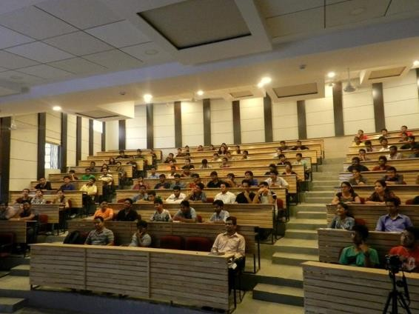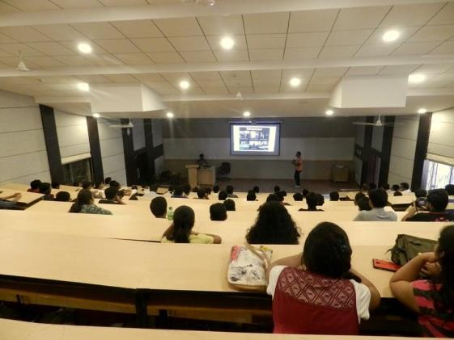

**Events during Monsoon ‘15**

**Bi-weekly E-talks:** Discussions on various topics ranging from the role startup ecosystems to sector specific ideation sessions.

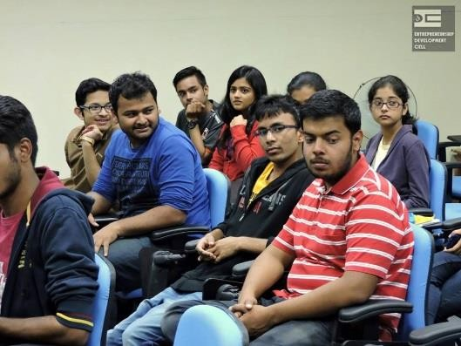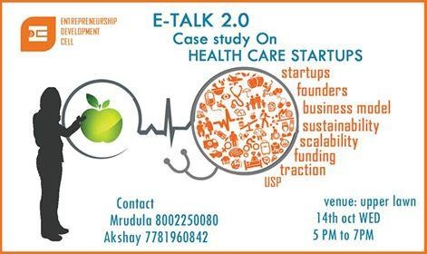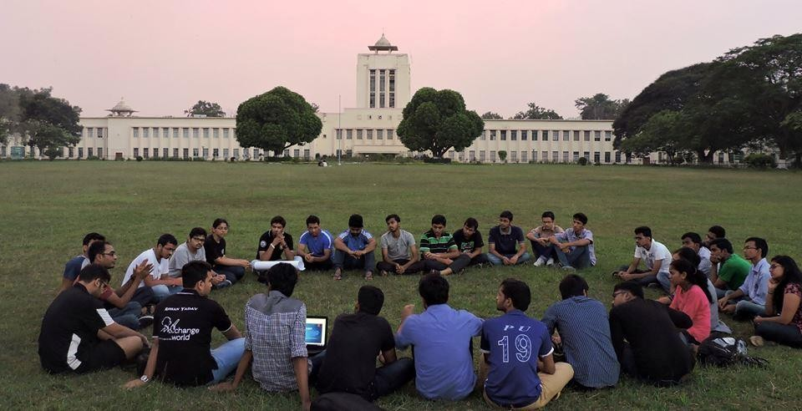

**Job vs Entrepreneurship debate:** This was a part of a task for the National Entrepreneurship

Challenge, IIT Bombay. Students participated to speak for or against Entrepreneurship .

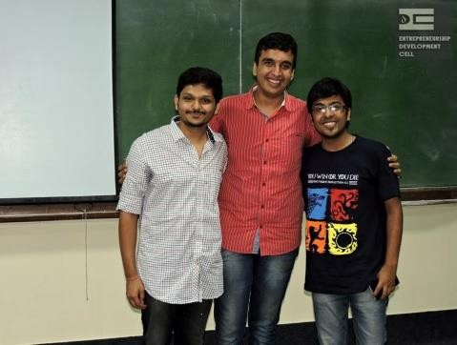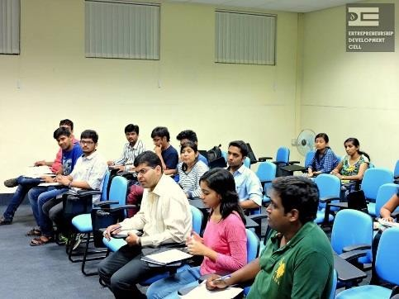

**Equity Research Initiative**

ERI is a company that provides training in finance and stock market analysis. It was started by BITS Pilani students. ERI in association with EDC BIT Mesra provided a course in stock market valuation. Some talented EDC members were selected by ERI and they were given the chance to learn stock market valuation over lectures and assignments in a period of 1 month. Those few selected students completed the course and were given certificate of appreciation for completing a very rigorous finance course.

For fostering the spirit of social entrepreneurship and imparting skillset to the deprived, EDC in collaboration with Dristi, celebrated Children's Day and Deepotsav in Panchauli village.

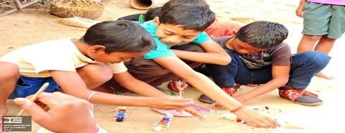

**Events during Spring‘16**

**E-Talk by MIT Sloan & BIT Mesra alumnus**: E-Talk with Mr. Pawan Gupta, Alumnus, MIT Sloan & BIT Mesra who shared how his entrepreneurial journey differed in BIT and MIT, and how an MBA from MIT Sloan helped him fulfil his entrepreneurial ambitions.

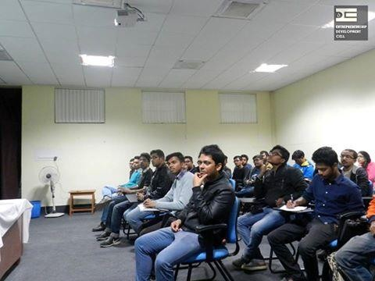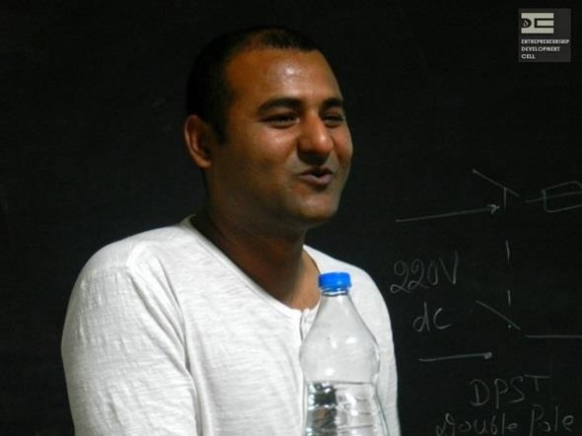

Team went to IIT, Bombay for participating in **Entrepreneurship Summit, IIT-B. Secured Rank 1**

among more than 150 competing E-Cells. [January 2016]

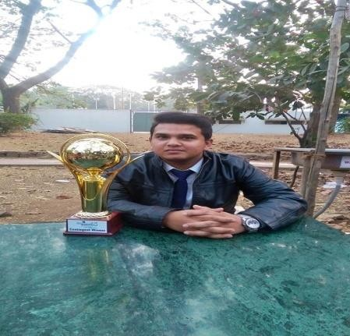

**Info-session by Indian School of Business on Young Leader’s Programme**

A member of the admission committee of ISB came down to campus to disseminate information about Young Leader’s Program in ISB. It was extremely helpful for 3rd and 4th year students. The entire event was coordinated by EDC BIT Mesra.

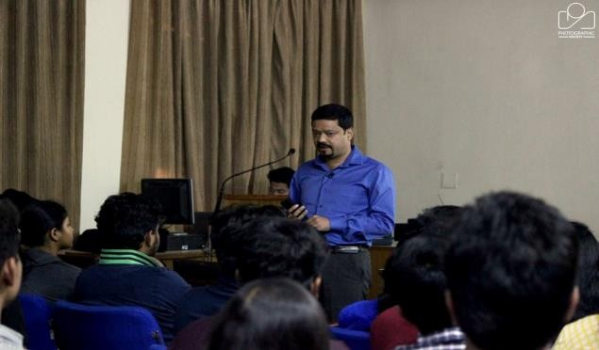

**MSME workshop**

A workshop was conducted by Micro Small and Medium Enterprises Ministry of Jharkhand. They made us aware about different ways by which we students can start up from college and gain funding. They also gave us insight into Start Up India scheme and how it can be beneficial to us.

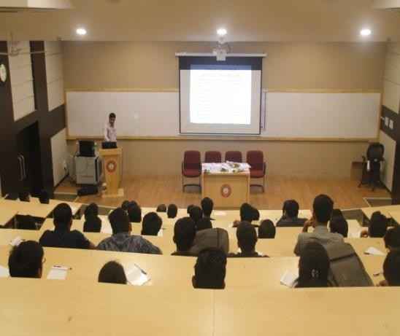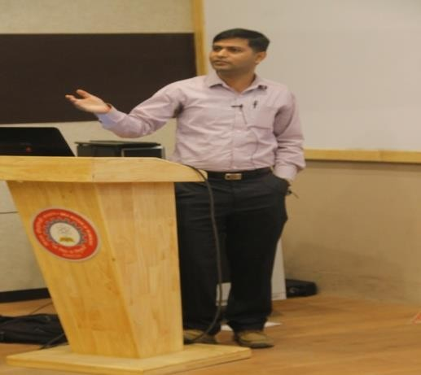

**Alumni meet**

Successful BIT Mesra alumni came to campus to interact with EDC members. EDC gave an presentation on it’s achievements and future plans. It received good support from the alumni. There was a pitching session where college students pitched their ideas and received funding assurance from the alumni. It was a fruitful meet where the alumni promised the students with complete support for their entrepreneurial ventures.

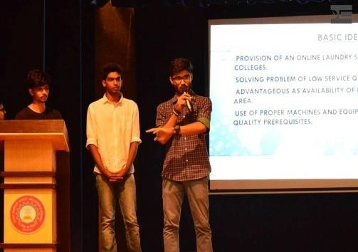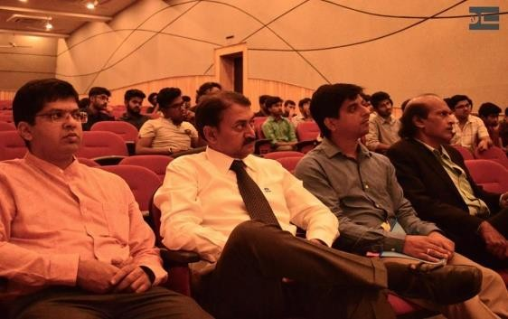

**Speech by SKILLSdox founder and president Bradley D.H. Loiselle**

He talked about how education is a human right and how he is focused on making education accessible to emerging markets. He believes in the potential of online education. He stresses on the importance of support that people provide to each other in course of their life .

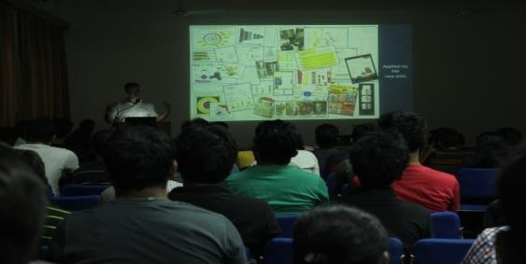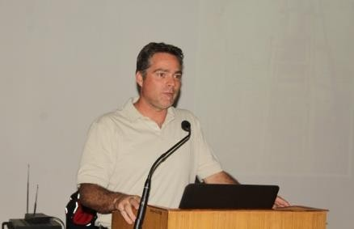

**ABOUT BIT ENTREPRENEURSHIP SUMMIT-2017**

60 years of edification, of par excellence, of philanthropically providing the country and the world with some of the best engineers of all times, our hallowed institution, the Birla Institute of Technology is the upshot of the vision of Mr. BM Birla, a man of great acclaim, a visionary and an industrialist!

Established 8 years after independence in 1955, Birla Institute of Technology (BIT), Mesra, has persistently risen to all the challenges that our new born liberated republic faced! One of the primes being that of streamlining the society by giving the country an erudite set of technical expertise!

BIT Mesra is, now, a premier-star rated college and is one of the most applauded colleges in the country!

**सा विद्या या विमक्तय** (Learning is that which Liberates) is what we believe; we preserve our heritage by making a statement through our acumen, our perseverance and by being pertinent in all facets of excellence being technically sound as well as socially and nationally responsible, thus, came up the concept of our entrepreneurship festival, the annual entrepreneurship fest of Birla Institute of Technology, Bites (Birla Institute of Technology Entrepreneurship Summit)!

To state it plain and clear, the Bites will be a 3-day annual national level entrepreneurship summit organized by Entrepreneurship Development Cell, Birla Institute of Technology, Mesra to support our prime minister’s vision of STARTUP INDIA, STANDUP INDIA, which will witness large scale participation of students from a copious number of top-notch colleges and professionals from various regions of the country. We will create a favorable environment to convince people to choose Entrepreneurship as a career option for through our well-structured workshops and competitions. We’ll have various guest lectures and panel discussions all focusing on increasing entrepreneurial skills of participants. That’s not all, we also have some nights including TVF Pitchers and Underground Authority.

**ENTREPRENEURSHIP MENTORSHIP PROGRAMME(EMP)**

**Apart from the above listed events, this year EDC BIT Mesra has taken few new initiatives of which most important is ENTREPRENEURSHIP MENTORSHIP PROGRAMME(EMP)**.

Details about the EMP in brief are furnished as-

**What is EMP?**

Entrepreneurship Development Cell-BIT Mesra has launched a new program called the EDC MENTORSHIP PROGRAMME (EMP) aiming at various colleges to help and mentor them in bringing about Entrepreneurial Change and setting up their own Entrepreneurship Development Cell in their colleges. EDC-BIT Mesra will be mentoring the colleges which have accepted for EMP and will provide them with full support to possible extent with some terms and conditions.

**Why is it required?**

In this competitive world where the corporate sector moves in very efficiently without any hassles but creating chaos. A question might arise- What Chaos? The answer is simple- Creating competition among jobs and the need for jobs. Entrepreneurship is not only just about creating jobs, it’s about solving the problems and working towards a social cause. The reason for an EDC in a College is to help students fund their startups and get all the facilities and experience, that too at a younger age.

Several other reasons include –

1. Lack of entrepreneurial knowledge

2. Less information available about Entrepreneurship.

**How it Works?**

EDC-BIT Mesra will form a team and those teams will be allocated with one College to discuss about EMP. Once the colleges accept our proposal of EMP (i.e. to mentor them and help them in setting up their own EDC), we will help them in not only just setting up their own EDC but also mentor the startups of the students from the prospective colleges. A MoU will be signed between the colleges and EDC to facilitate the functioning.

EDC BIT Mesra-EMP would help other colleges to get the students to a higher level of understanding of Corporate world, as EDC BIT Mesra is quite known for organizing seminars and workshops –helping students develop the qualities required.

**A simple yet effective solution for all the above reasons is a place where they can be asked and mentored- EM0P.**

Descriptive analysis of the problems-

1. **Lack of Entrepreneurial Knowledge:** People around us are not completely aware about what entrepreneurship is and what it deals with resulting in chaos and misconceptions about entrepreneurship as career.

2. **Less information available about Entrepreneurship:** Students despite having ideas about the starting up don’t know whom to approach, how to approach which is why many brilliant ideas are not getting the attention and mentorship required. Entrepreneurship deals with wide

range of terms and aspects which may even lead to very adverse consequences, due to which students and others fear about it not knowing what it exactly means and what to do when problems struck.

Solution of the problems-

The solution of all above mentioned problem is Entrepreneurship Cell, a organization which works with a aim to support students in starting up. Main aim of an E-Cell is to promote Entrepreneurship among students and professionals of college as a career path.

So Entrepreneurship Development Cell-BIT Mesra will help all colleges without E-Cell to establish one at their campus through EDC Mentorship Programme.

Planning and Execution-

EDC Mentorship Programme will be divided in three phases. First phase will be focused on development of E-Cells in colleges of Ranchi, Jamshedpur, Dhanbad district. Second Phase will cover colleges of all other districts in Jharkhand. In third stage of EDC Mentorship Programme it will extend it arms to other states in the country. EDC-BIT MESRA will provide a mentor all colleges for three years. In first year of the Programme each college will be mentored to establish an E-Cell at their campus, to support the growth of E-Cell EDC-BIT MESRA will organize various workshops, guest lectures, Events at the respected campuses. In second and third year of the programme after establishment of E-Cell at each college EDC BIT MESRA will mentor these E-Cells for smooth functioning and will help these cells to become self sustainable.At the completion of this programme each college will help a well- established and self-sustaining Entrepreneurship Cell at their campus.

We plan to mentor several colleges under Phase-I of EMP and provide them with all the facilities and services for three complete years. The districts that are to be covered in Phase-I are Ranchi, Jamshedpur, Dhanbad. The following colleges are to be invited as a part of Phase-I:

1. BIT Sindri

2. Government Polytechnic, Ranchi

3. Government Women’s Polytechnic, Ranchi

4. Government Women’s Polytechnic, Jamshedpur

5. Government Polytechnic, Dhanbad

6. Government Mining Polytechnic Institute, Dhanbad

7. Ranchi College, Ranchi

8. NIT Jamshedpur

9. National University of Study and Research in Law, Ranchi

10.Birsa Agricultural University, Ranchi

11.National Institute of Foundry and Forge Technology, Ranchi

12.Xaviers’ Institute of Social Service (XISS)

13.Amity University

The following flowchart explains in brief our plan-

EMP STARTS

COLEEGE ACCEPTS OUR MENTORSHIP

PROCESS FOR TEAM CHECK OF STUDENTS AT CAMPUS

COLLEGE HAS A

GOOD AND NO

ENTHUSIASTIC TEAM

VISIT CAMPUS AND FORM A GOOD TEAM OF STUDENTS



YES

VISIT CAMPUS FOR INTRODUCTION AND PRESENTATION ON WHY ENTREPRENEURSHIP AND WHY E-CELL



ORGANIZE A WORKSHOP ON BASICS OF ENTREPRENEURSHIP

ORGANIZE A GUEST LECTURE BY EMINENT PERSONALITY

DURING 2ND – 4TH MONTH

EVALUATE THE LAST TWO EVENTS AT THE CAMPUS

RESULT OF EVALUATION

NEGATIVE

POSITIVE

5TH MONTH

ORGANIZE A COMPETION AT THE CAMPUS

22

7TH - 10TH MONTH

11TH MONTH

ORGANIZE ONE MORE WORKSHOP AND GUEST LECTURE

PROVIDE TEAM WITH RESOURCES TO ESTABLISH A CELL

EVALUATE THE FINAL RESULT AT THE END OF THE YEAR

END OF 1ST YEAR

2ND AND 3RD YEAR

RESULT OF EVALUATION

POSITIVE

MENTOR E-CELL FOR PROPER FUNCTIION FOR 2 YEARS and ENSURE SELF SUSTAINABILITY OF THE CELL

NEGATIVE

Phase-I includes Ranchi, Dhanbad, Jamshedpur districts.

Phase-II includes expansion to other districts of Jharkhand.

Phase-III includes expansion

to other states in the Country.

MENTORSHIP ENDS

**POPULATION SERVED(demographics)**

Youth 16 to 35 years old : in 1st phase 20,000 [(@2000](mailto:@2000) students per college)

**OUTCOMES AND EVALUATION**

All students of Colleges will be full aware about Entrepreneurship.

College will get a full functioning E-Cell at end of Program.

This program will help the STARTUP INDIA STANDUP INDIA to achieve its goal

**PARTNERS**

EDC-BIT Mesra strongly believes that the formula for providing effective, cost- efficient and high quality programs includes collaboration with many community organizations.

So, EDC-BIT Mesra will partners with the following groups:

Student Groups of College– identifies children for the programs

Library – provides knowledge centre

EDC Executive Members - serve as volunteer tutors and mentors

(university/college) students – serve as volunteer

Other Local Businesses – provides funding for facility and enhancements

College/University– provides space for Events

NASSCOM - serve as resource for workshop and guest lectures

**SUSTAINABILITY OF PROJECT**

To serve eligible colleges under EMP, EDC BIT-Mesra has developed a fund raising plan which includes initiating an annual fund drive targeted to government organizations, individuals, local businesses; funding requests to area civic clubs and organizations; and corporate and foundation grants.

**PUBLICITY**

EDC BIT-Mesra will be pleased to acknowledge your contribution with appropriate signage at the facility. In addition, we would make mention of your organization in our monthly newsletter, website, blog and submit news releases to local newspapers.

**REQUEST**

EDC BIT-Mesra requests a grant of Rs.5,00,000 to initiate and develop the

EDC Mentorship Program which will make a meaningful difference in the lives

of our area’s youth and help create an entrepreneurial environment in Jharkhan.

**BUDGET INFORMATION**

Revenues:

Proceeds from this request Rs.20,20,000/- TOTAL REVENUES Rs.20,20,000/-

Expenditures:

1. Promotion Rs.1,50,000/-

2. Stationaries & other capital expenses Rs.1,00,000/-

3. Printing & publications Rs.1,50,000/-

4. Capital investment for office controlling the EMP- Rs.4,00,000/-

5. Travel Rs.4,00,000/-

6. Accommodation Rs.3,00,000/-

7. Event Conduction & Guest Lecture form the Dignified Entrepreneurs of

India Rs.4,20,000/-

8. Other expenses Rs.1,00,000/-

TOTAL EXPENDITURES Rs.20,20,000.00

JUSTIFICATION OF BUDGET

1. Promotion Rs.1,50,000/-

Rs. 15,000/- per college will be allotted for 10 colleges selected in phase

1.EDC will send 1 team of student to each college to promote the program.

2. Stationaries & other capital expenses Rs.1,00,000/-

A4 size papers and other materials like pen, pencil, chart papers etc. will be purchased for conducting different events at all colleges at the rate of Rs. 10,000/- per college.

3. Printing & publications Rs.1,50,000/-

Rs. 15,000/- will be allotted for each college for printing posters and pamphlets for events occurring over there and also including decoration of stage and hall.

4. Capital investment for office controlling the EMP- Rs.4,00,000/-

5 Computers (@ Rs. 60,000/-)- Rs.3,00,000/-

3 Printers (@ Rs. 10,000/-)- Rs. 30,000/-

1 Projector (@ Rs 50,000/-)- Rs 50,000/-

Stationaries and other requirements (System maintenance and printer ink etc.)- Rs. 20,000/-

5. Travel Rs. 4,00,000/-

Air Fare of personals coming for 20 Guest lectur[es (@12](mailto:@12),000 per person)-2,40,000

Road Travel and Others for 20 guests (@ 4000 per guest)- 80,000

Travel cost of EDC BIT- Mesra students visiting each college (@ Rs.

8,000/- per college)-Rs. 80,000/-

6. Accommodation Rs. 3,00,000/-

Accommodation for guest (@ Rs. 3,000/- per guest)-60,000/-

Accommodation for Students when going to other cities (@ Rs 8,000 per event for 30 events)- Rs. 2,40,000/-

7. Event Conduction Rs. 4,20,000/-

Arranging for different assets for events (like PA System, Projectors etc.) @ Rs 4,000/- per event for 60 events – Rs. 2,40,000/-

Sending team and resource to college (@ Rs 3,000/- per event for 60 event in 10 colleges)- Rs. 1,80,000

8. Miscellaneous expenses Rs. 1,00,000/-